So-Long Battery – Solar Harvesting System
Kimberly A. Sasso
Student ID: 101-50-624
Kimberly.Sasso@student.fairfield.edu
ECE 0551 02: Thesis II
December 9, 2015

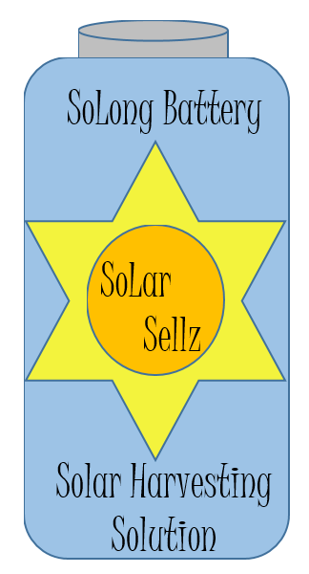
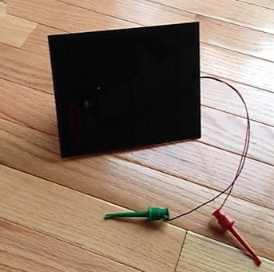

Table of Contents
1.0 Introduction: So-Long Battery – Solar Harvesting System 3
1.1 Problem Statement. 4
1.2 Approach 5
1.3 Motivation 16
1.4 Ethics 17
1.5 Standards 18
1.6 Validation 19
1.7 Gantt Chart 23
2.0 Design 24
3.0 Data 33
4.0 Packaging 35
5.0 Marketing 37
6.0 Conclusion 38
7.0 Historical Survey 40
8.0 Literature Survey: 44
Appendix A: Schedule 49

Introduction: So-Long Battery – Solar Harvesting System
An electronic circuit will be created that will obtain Solar energy and utilize it to provide 3.3VDC or 5V DC output. The electronics fabrication was originally intended to be constrained to the dimensions of an AAA battery bank (20mmx40mm) [1] footprint but development of the product led to a modification to this specification. The circuit will utilize a method known as Energy Harvesting where “energy is collected from the instrument’s immediate environment, offering perpetual operation with no connection to the
grid and minimal or no maintenance requirements” [2]. In the case of the circuit being proposed, light will be the energy harvested and the electronics will be the system by which the energy is collected, stored, and delivered to a device requiring 3.3VDC or 5VDC power.

Sunlight will be gathered through a photovoltaic source, also known as a Solar cell. Solar cell devices are becoming cheap enough for utilization in small projects due to demand and advances in technology. They are appealing to incorporate into harvesting applications “because of [their] relatively high energy output. Photovoltaic energy harvesting can be used to power wireless sensor nodes, as well as higher power battery charging applications to extend battery life, [and] in some cases eliminating tethered charging altogether” [3]. The intent of this project is to create a “non-tethered” power solution that can be utilized by devices running off of 3.3VDC or 5VDC.

1.1 Problem Statement.
“Harvesting energy from the environment has been proposed to supplement or completely replace battery supplies to enhance system lifetime and reduce the maintenance cost of replacing batteries periodically” [4]. Devices that exist today utilize batteries which require periodic hands on contact. A plug in power supply can also be utilized as an alternate power source for many devices and are subject to issues if there is a power failure. The power harvesting circuit discussed in this paper will provide the freedom to energize circuitry without the concerns that arise with the current input power solutions.

The Solar energy that is collected by the Solar cell will be stored in a supercapacitor. The harvested energy will be conditioned to supply 3.3VDC or 5VDC output to a power connector. The design will incorporate a power monitoring system that will automatically cycle between buck and boost mode to ensure that the power provided remains constant at 3.3V or 5VDC. “To cater for different light intensities, we track the voltage of the PV cells to determine whether the charge pump is used or bypassed. Under low light intensity, the PV voltage is low and the charge pump steps up the voltage” [5] to the circuit. The switching between buck and boost mode is necessary for optimal power output. “[The] tracking unit monitors the charge pump output power and determines the adjustment of the system operating parameter. Based on the adjustment decision, the control unit tunes the operating frequency of the charge pump in order to maximize the system' power output” [5].

1.2 Approach
The Supercapacitor So-Long Battery – Solar Harvesting System will ideally utilize a Solar cell interface (or SMD cells mounted on the PCB) to collect Solar energy, but a Solar cell may be required for desired energy collection. The Solar cell selected provides voltage ranges from 7.0Vdc to 0Vdc depending on the intensity of the excitation light level. The energy collected will be routed through a charging circuit to a supercapacitor configuration mounted inside a single package. The output from the charged supercapacitor(s) will be fed into a buck/boost DC-DC converter which will regulate the output voltage to 3.3VDC or 5VDC depending on the design. For either design, the output voltage is an adjustable output which can be changed with resistor configurations.

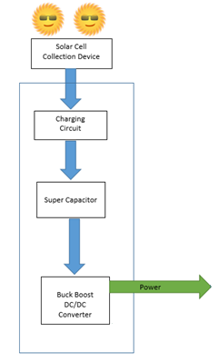
Figure 1.2-1 Power Harvesting Block Diagram.

“There are two main challenges associated with indoor energy harvesting: 1) ambient energy sources in the indoor environment are very weak, hence the harvested power is much lower than that of the outdoor condition; and 2) availability of energy sources are dependent on the indoor environmental conditions” [3]. To ensure proper charging of the circuit, an evaluation of the Solar cell output will be made under various light level conditions to characterize the cells reactivity to light. This mapping of photovoltaic cell response to light conditions will help define the performance specifications and limitations to the power harvesting system.

Due to the challenges associated with indoor harvesting, the first consideration to be made in the device development is which Solar cell will be utilized in the design. There are several different types of cells available. Evaluating each based on the amount of output power provided will be the determining factor regarding which component to purchase. The original component being utilized in this design was a Radio Shack® 1W, 6V Solar panel (Model P1060) [6]. As the development effort progressed, a 3W, 6V Solar cell was selected for use in the final configuration.

The capacitor charging integrated circuit must have an input voltage limited to 5.5VDC (max), with an input current no larger than 3A; therefore, careful consideration of a Schottky diode is necessary to ensure proper electrical ranges for the LTC3625 charging IC. The LTC3625 has an internal monitor in the circuit that will monitor the input voltage level and will disable the part if the input voltage falls below 2.9Vdc. [7] In addition, the IC has a built in DC–DC converter with maximum power point tracking (MPPT) capability. The MPPT is not necessary for the design to work successfully but is highly desirable when trying to optimize the capacitor charging levels in any power harvesting system. The MPPT will adjust the load coming out of the cell to maximize the current that can be delivered by the part. “The maximum power point (MPP) is the best operation for a PV module to provide as much power as possible. However, the MPP for a PV module varies with incident light irradiance. In order to improve efficiency, MPPT technology is always utilized in a solar energy harvest system to ensure the PV module works at its MPP” [8].

Another feature of the LTC3625 that makes it appealing for use in this design is that there is an “automatic cell balancing [feature which] prevents overvoltage damage to either supercapacitor while maximizing charge rate” [7]. This is important to supercapacitor harvesting designs because “some properties of super-capacitor like voltage, current, resistance and capacitance are discrete and inconsistent between different super-capacitor units, mainly because of inherent distinctions in product manufacturing. These [mismatched] parameters will cause voltage imbalance, and even decrease the lifetime of super-capacitors” [9].

“To cater for different light intensities, we track the voltage of the PV cells and the battery to determine whether the charge pump is used or bypassed. Under low light intensity, the PV voltage is low and the charge pump steps up the voltage [for] powering the circuit. At the same time, the optimal power tracking unit monitors the charge pump output power and determines the adjustment of the system operating parameter. Based on the adjustment decision, the control unit tunes the operating frequency of the charge pump in order to maximize the system power output” [10]. The MCP1252-ADJ charge pump will be utilized in this design. The component output is configurable from 1-5.5VDC [11].

Replacing a rechargeable battery with a supercapacitor is more efficient because the capacitor can be power cycled more times than a rechargeable battery; therefore, there is extended life in the circuit. There is also the added benefit that the power delivery from the supercapacitor occurs much faster than traditional means, so the power delivery is more efficient [12]. Supercapacitors have “Very high rates of charge and discharge; little degradation over hundreds of thousands of cycles; Good reversibility; [they are] light weight; low toxicity of materials used; and have high cycle efficiency (95% or more)” [12] .The supercapacitor chosen for this design is a dual bank 1.2F, 5.5V supercapacitor (P/N: HS230F1.2F) [13]. Previous supercapacitor designs resulted in very large packages which made it impractical to implement in a battery replacement design. The foot print for this part is 17x44mm [14] which makes it very desirable for insertion into a Solar harvesting power source. The part is fairly expensive, so this capacitor may change during the cost and design analysis.

As long as the input voltage to the LTC3625 remains in the operational range, the circuit will charge the supercapacitors [7]. The output at the capacitors is set for 4.8VDC which is in the desired 5VDC range that the design platform requires. There will be a second stage to this circuit which consists of an MCP1252 charge pump. The operating voltage range is 2.1-5.5VDC therefore the desired output voltage should be present as long as the input voltage detected by the LTC3625 enables the charging of the supercapacitor. The output voltage of the MCP1252 can be higher than the input voltage due to the fact that there is automatic switching between buck/boost functions [11]. This automatic switching function also removes the requirement for an adjustable duty cycle of the power level. Lastly, if a situation arises where the power falls below the safe operating conditions of the operating range, a Power/Shutdown will enable or disable the microprocessor before it can be damaged.
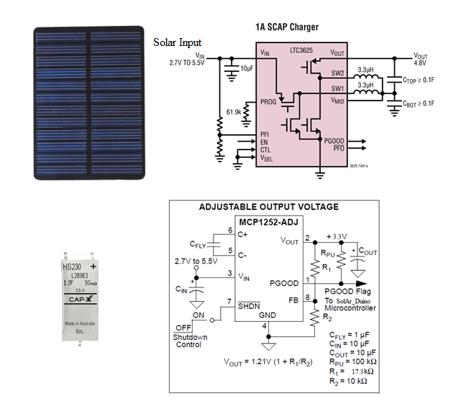
Figure 1.2-2 Block Diagram of System.
Note images taken from [6], [7], and [11].

Accurate costing estimates for the design can be taken from the preliminary bill of materials (Figure 1.2-5) created for this project. The cost of the design seems quite high at close to $100 for components alone for the first piece prototype build. Non recurring Engineering (NRE) costs also need to be considered in the development process, and in this design will be approximately $2600. These high costs are normal in development cycles because of the small build quantities being dealt with. When analyzed over a larger build quantity, the cost decreases dramatically. Figure 1.2-3 illustrates that the cost is cut in half once the 100 piece build quantity is examined. In the case of this design, that cost is still quite high therefore a scrub of the design will be performed that targets cost reduction. The NRE costs usually are a one-time cost which is regained in the profit that is made by the volume of product that is Sod in the market. Things to target for cost reduction when evaluating this bill of materials are capacitor costs, Solar cell costs, and packaging costs.

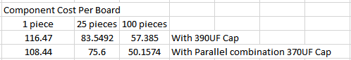
Figure 1.2-3 Cost Breakdown by Build Quantity.
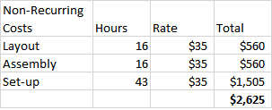
Figure 1.2-4 NRE Costs.

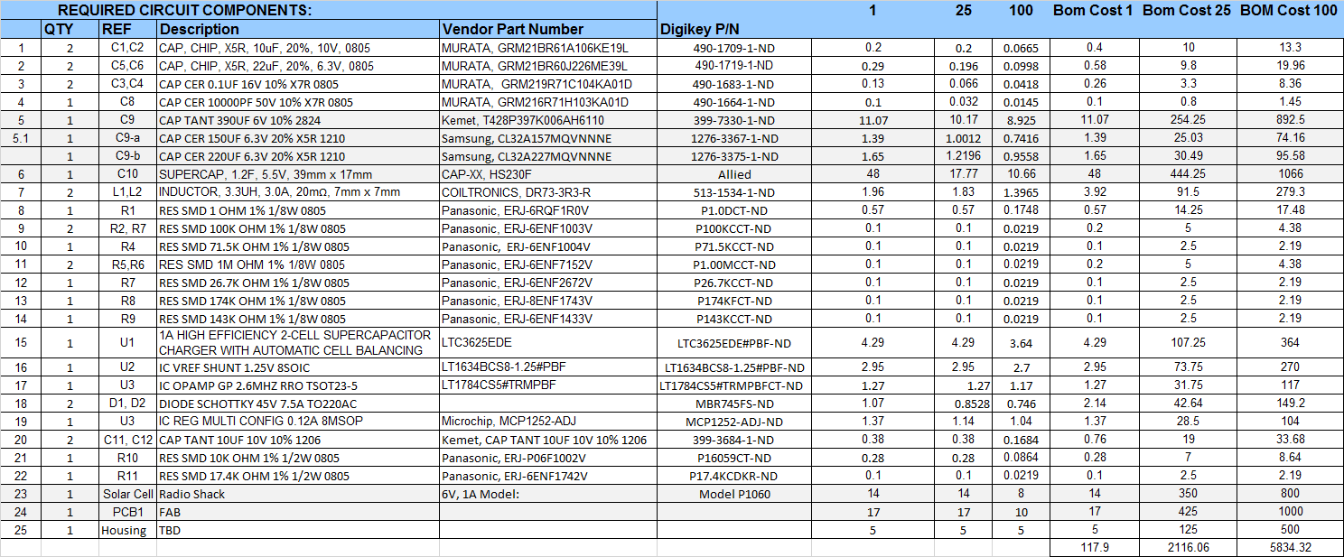

Figure1.2-5 Preliminary Bill of Materials.

The schematic in Figure 1-2.7 incorporates suggestions that the manufacturer includes as part of the data sheet application notes. The top section of the schematic incorporates the proposed typical application for the Solar Powered SCAP Charger with MPPT configuration of the LTC3625 [7]. The regulating charge pump circuit was derived from the MCP1252 Adjustable Output Voltage typical circuit application [11]. The prototype circuit will need to be tweaked with component modifications in order to maximize the desired performance of the design.

Note: The first prototype had been completed March 30, 2015 and worked as intended in direct sunlight.
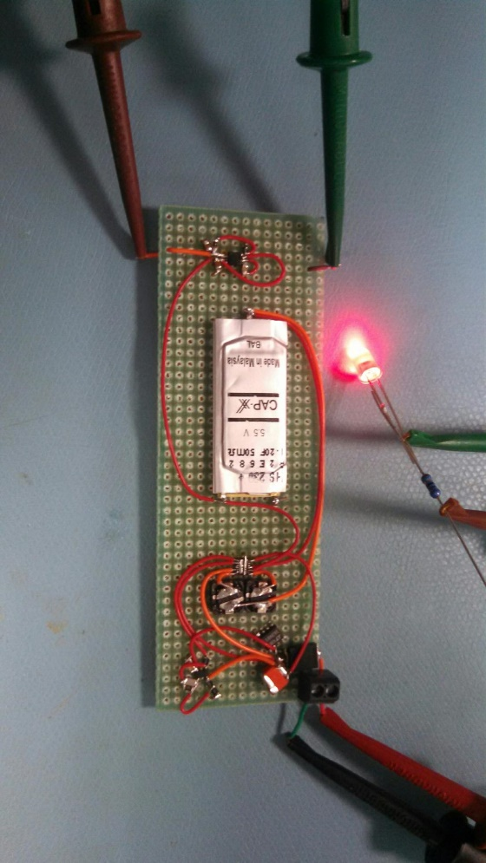
Figure 1-6.8: Prototype Circuit Utilizing Solar Cell Excitation as the Energy Source.

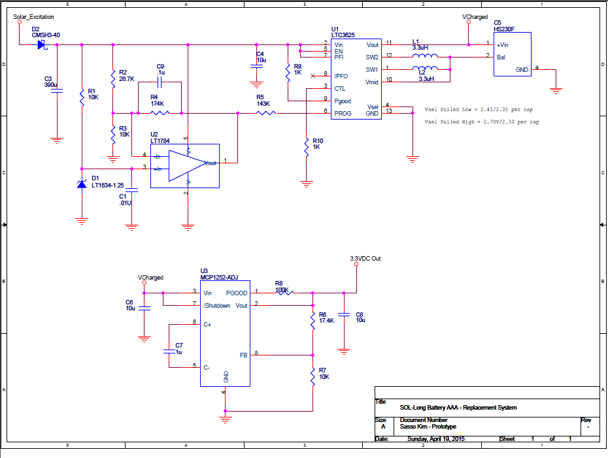

Figure1.2-7 Preliminary Schematic.

“The world alkaline battery market generated $6.5 billion to $7 billion during 2010. It is expected to grow at a compound annual growth rate of 3 percent to 4 percent” [15]. For the purposes of market share, it is assumed that the midpoint for these statistics will be utilized for projection of future sales of alkaline batteries. Figure 1-2.6 shows the projected growth in sales of alkaline batteries through the year 2025. Out of all of the battery sales the statistics show that between 25% and 30% of those sold were the AAA format [16]. Figure 1-2.6 also illustrates the sales growth potential for AAA batteries over the same time frame. Based on this data, the projected sales for alkaline batteries alone will be over $11billion. The most amazing part of this is that the majority of the batteries sold will end up in a landfill.

Figure 1-2.6: Projected Sales of Alkaline Batteries from 2010 to 2025

The target market for this product will be any person utilizing AAA batteries to power an electronic device. The goal would be to gain 1%-2% of the market share. Figure 1-2.7 illustrates that projected sales could run into the millions. When evaluating the price point for the So-Long Battery Solar Harvesting System, the price point for rechargeable AAA batteries were looked at on Amazon.com. Four pieces were being offered for sale in addition to the battery charger which costs about $20. This data indicates that the price point for a battery replacement product like this should be moderately received around $30 but well received around $20. Since the cost for 100 pieces is currently estimated to be around $50, the quantity of product Sod will have to be between 500 and 1000 pieces before any profit would be recognized.

Figure 1-6.7: Projected sales of So-Long Battery- Solar Harvesting System
Assuming 1% and 2% of market share.

To help with the NRE costs, the project will be introduced on www.Kickstarter.com where a completed assembly will be provided to those who donate funds for developing it. The goal will be to raise $7000 that will be utilized to kit for and build 100 initial pieces. This build will take place after the first 5 prototypes have been built, validated, scrutinized, and revised to ensure that a solid product can be launched to the public.

1.3 Motivation
The So-Long Battery - Solar Harvesting System should be created for end users who require a portable power collection and storage device for their application. This is a significant requirement because current usage of electronic devices are limited to a plug in power source or a battery which has a limited life. If the device can be power independent, then the places where it can be utilized are expanded, and usage of the device can be constant without interruption due to power loss. The contribution to the appropriate body of knowledge: By producing this harvester, consumers can extend the reaches that such devices currently have due to the limitations of the power structure that currently exists. The wider principles that emerged from the research are mainly centered on the solar collection methods. The industry is constantly changing and it will be beneficial if a more efficient placement of the Solar collectors can be developed. The current solution is to harvest more than 1 type of energy to resolve the luminescence issue.

People in the field can use the device for any microprocessor type of application running on 3.3V or 5VDC with a low current demand. As the electronics industry progresses, storage devices such as the supercapacitor will improve. Over time, the replacement of batteries with energy harvesters could possibly happen. It starts with projects like this one. This application is appealing because renewable energy is the trending power technology. What makes this unique to the market is that instead of batteries, or DC power being supplied through a transformer, this design will utilize the technology to provide consumers a whole new avenue for their devices.

1.4 Ethics
Creating devices that utilize renewable energy can be a benefit to society because some current methods of power delivery can be harmful to the environment. If a battery is utilized and then thrown into the garbage rather than properly disposed of, it can create a situation where harmful pollutants can leach into the ground water. By eliminating the need for batteries, a reduction of waste may be possible.

Another reason to introduce this type of solution to the end user is to ensure continuity of data. The creation of a self-powered remote collection device removes the disruption to a test bed that would transpire during a battery replacement. When using a self-powered supply, the device can stay in a fixed location for as long as necessary without disturbance to the sensors and any other cabling that may be attached to the project. The relay of collected data through wireless transmission also takes the issue of human factor out of the data collection process. Mistakes that can be introduced into the data by a human error become non-existent because there is a fixed cycle, automated process that ensures consistency in the collection process.

Other things to consider are the integrity of the design, and how it impacts the user from a safety perspective. The packaging must be evaluated to ensure that the user of the product does not receive a shock when they connect the So-Long Battery-Solar Harvesting System to their portable device. The need to ensure that the harvester can mount to the device without causing electrical or physical damage to it is also of big concern. The integrity of the materials that are utilized in the manufacture of the product must be scrutinized to ensure that there is a reasonable life cycle to the product.

1.5 Standards
Specifications that will be utilized for design validation will include:

For layout standards of the design: IPC2221B: Generic Standard on Printed Board Design

For any tests that will be implemented during the validation process: IPC TM-650 Test Methods Manual.

For Soldering and assembly verification: IPC J-STD-001: Requirements for Soldered Electrical and Electronic Assemblies

For inspection of assembled pc boards: IPC-A-610: Industry-Accepted Workmanship Criteria for Electronics Assemblies.

For power validation: Closed loop tests for performance evaluations of controlled DC-DC switching converters.

1.6 Validation
For the validation of the design, project monitoring will be used along with a case study to create the definitions that I will design my product to. Prior to implementing the design, a Solar cell output map will need to be created for the light level conditions that the product will function in. This characterization will inform the operational requirements and establish performance criteria. This data will be obtained utilizing a DVM. Later a correlation will be made from measured V_{OUT} to a luminescence value. When the data is taken, Height is 1M from ground with cells exposed parallel to the sun and with no obstructions in the light path.

Establishing Functional Charging Range
Light Excitation Level | Solar Cell 1 V_{OUT}  (Volts) | Solar Cell 2 V_{OUT}  (Volts)
Snowy Overcast Day | 6.44 | 5.144
Inside Ambient Light Snowy Overcast Day | 3.45 | 1.55
Rainy Overcast Day | 4.69 | 2.99
Inside Ambient Light Rainy Overcast Day | 3.45 | 1.55
Sunny Bright Day | 7.23 | 6.91
Inside Ambient Light Sunny Bright Day | 5.05 | 2.75
Dusk | 0.62 | .06
Inside Light On | 4.32 | 2.04
Inside Light On / Dark Outside | 2.74 | 0.71
Table 1.6-1 Light Level Output from Raw Solar Cells

After the data has been collected in Table 1-6.1, a selection of the correct Solar cell can be made and the Harvested Vh _{(IN)} functional range will be defined. This will help in selecting the diodes that will be needed to protect the charging circuitry from receiving too much input voltage. There will also be a clear picture as to whether the charging circuit will work indoors as well as outdoors, and under what conditions.
Next, the Simulation Controlled Execution of the design will transpire. The electronic circuitry will be defined, and then will be simulated utilizing the data obtained in phase 1. The output will be evaluated for accuracy against the initial concept and some tweaking to the design may take place if required. Once the simulation is complete, the design will be created on a breadboard and then tested. The ideal conditions will be that the simulation and the actual results match. If they don’t, then more tweaks will be required to lock in the functionality of the design.

Circuit Performance Based on Light Level
Solar Cell V_{IN} | VDiode | V_{SuperCapacitor}  (Volts) | V_{REG}  (Volts)
6.50
6.00
5.50
5.00
4. 50
4.00
3.50
3.00
2.50
2.00
1.50
1.00
0.50
0.00
Table 1.6-2 Light Level Output from Raw Solar Cells

After the Supercapacitor circuitry has been designed, laid out, and fabricated, it will be necessary to verify that the function of the harvester works as it was intended to. In order to validate the design, it will be necessary to measure some key data points on the hardware while the harvester is running. The data will be taken and recorded in Table 1-6.2 with observational, simulated, and controlled methods to ensure that the circuit works as intended.
A test bed (represented in Figure 1.6-1) will be created to simulate the light source input level. In the real world, a DC power supply could replicate the voltage input at the varying levels of light and the testing would cover the light spectrum from complete darkness to full brightness (equivalent to the light level present on an average sunny day).
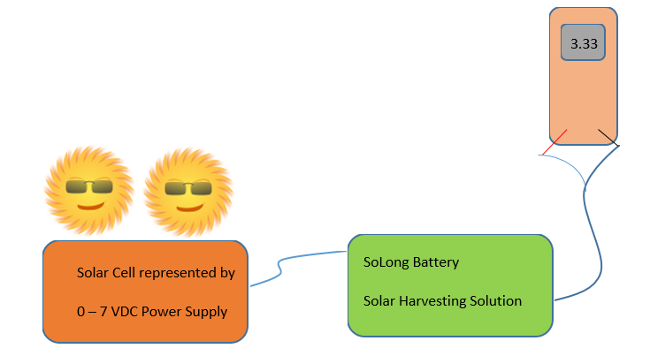
Figure 1.6-1 SoLong Battery Test Bed

While subjected to each of these light level conditions, certain points will be measured on the So-Long Battery – Solar Harvesting System to evaluate the performance of the charging circuit, and the output of the DC to DC converter. In addition, or as an alternative, the voltage representative values of the light level could also be monitored by a sensor to simulate the conditions that were obtained in Phase 1 of the validation process.
Circuit Performance Based on Light Level
Solar Cell V_{IN} | VDiode | V_{SuperCapacitor}  (Volts) | V_{REG}  (Volts)
6.50
6.00
5.50
5.00
4. 50
4.00
3.50
3.00
2.50
2.00
1.50
1.00
0.50
0.00
Table 1.6-3 Light Level Output from Raw Solar Cells

The goals of this testing are:
- To determine the optimal Solar cell to incorporate into the design;
- The appropriate light level required for adequate performance of the supercapacitor charging circuit.
In addition, the charging and discharging characteristics of the supercapacitor will be characterized and understood for power management purposes. The last goal is to implement a stable power regulation system that will have the appropriate power management to ensure that the device utilizing the output power and the supercapacitors are not damaged in the application.

1.7 Gantt Chart
The Gantt chart shown in figure 1.7-1 is a general overview of the scope for the SoLong Battery - Solar Replacement project. A detailed development Gantt chart can be found in Appendix A.

Figure 1.7-1 Gantt Chart – So-Long Battery Project Overview

Design
The prototype for the battery replacement circuit was built in accordance with the schematic in Figure 2.0-1. The circuit worked as intended and was fully operational in direct sunlight. In the original prototype, the capacitor that was chosen was a high energy capacitor with an extrememly quick discharge that had a cost of about $18. As a means of reducing BOM costs a new capacitor was selected and then incorporated into the prototype design. During indoor testing, the circuit did not function optimally. After a little investigating it became apparent that the LT3625EDE Supercapacitor charging chip was the culprit. The chip that was utilized in this design had a minimum input requiremet of 2 V. When using a 3W Solar cell, the cell provides a source volatge as low as 0.6V with ambient indoor lighting as the stimulus. The 2V operating requirement of the Linear Tech part limited the design to only functioning in daylight outdoors. One of the goals of this design was to harvest the indoor ambinet light, therefore a new approach needed to be investigated. A decision was made to carry this design into the next phase however because a 5VDC harvester for outdoor use is an appealing design for the cell phone charging market. 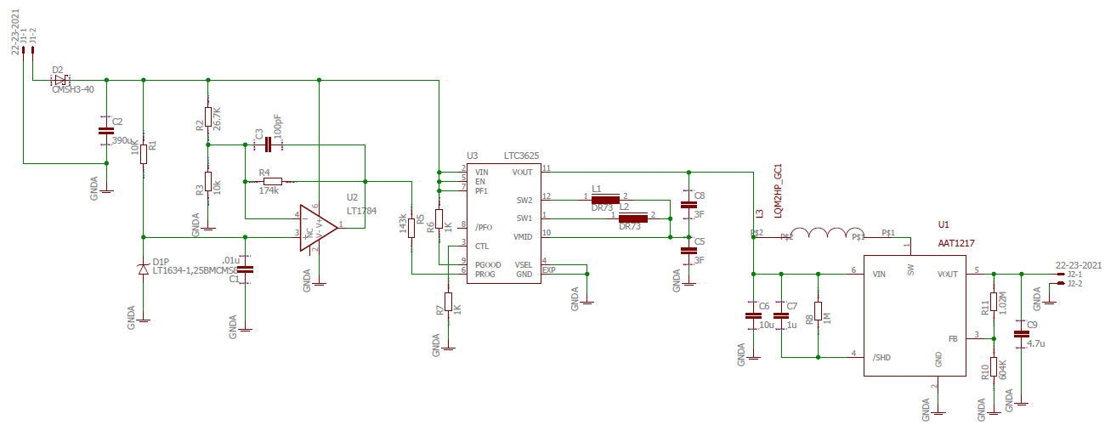
Figure 2.0-1: Solar Harvesting schematic - circuit utilizing LT3625EDE

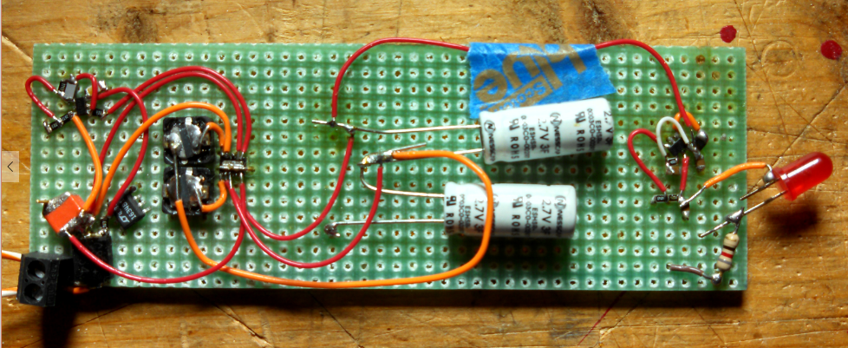
Figure 2.0-2: Prototype Board utilizing the utilizing LT3625EDE
After researching different harvesting chips, a second design was prototyped utilizing the LTC3105 chip which is a 400mA step-up DC/DC Converter that has Maximum Power Point Control and a 250mV Start-Up [17]. The appeal of this chip is that the component will operate with an input voltage of 225mV to 5Vdc. In this design, the 9F capacitor was incorporated for harvested energy storage. The secondary stage of this circuit utilized the same components that were in the third stage of the original prototype. A preliminary schematic, (Figure 2.0-3) was created and the prototype was then made to prove out the concept.
The prototype circuit was completed and tested in ambinet light conditions. The testing yielded favorable results with the new Linear Technology component. The 9F capacitor charged with a lower Solar cell input voltage (1.5v) but the demand for current from the Solar cell by the circuit caused the Solar cell input to drag down. The next step was to obtain a more powerful Solar cell and test with the new circuit. The testing results in the sunlight were as expected. The analysis of the test results indicated that the battery replacement with this approch is feasible, but in order to properly implement, a smaller capacitor or larger Solar cell would have to be utiized. The second prototype circuit is more desireable for two reasons: there are less parts, which makes it easier to manufacture, and cost - the final product will also be less expensive. The new Solar cells being analyzed will be 2.5 W and 3 W – 6V cells.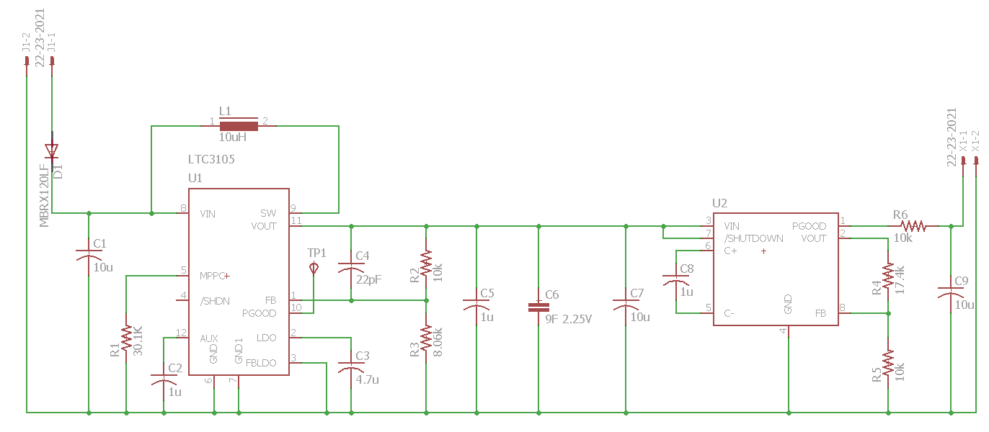
Figure 2.0-3: Solar Harvesting schematic - circuit utilizing LTC3105
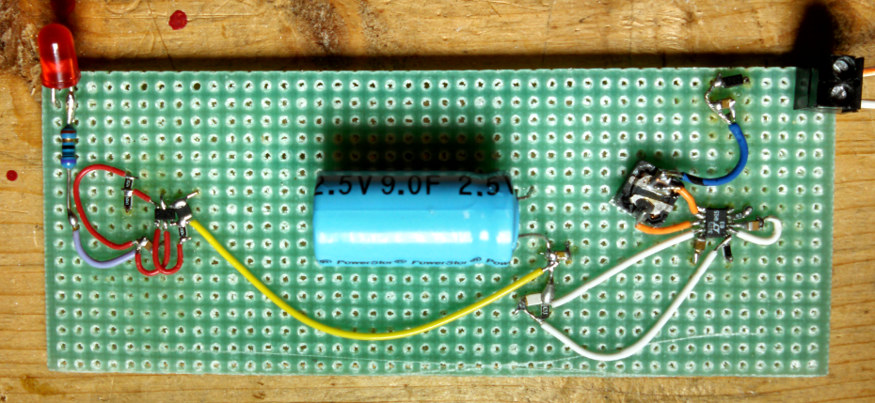
Figure 2.0-4: Prototype Board utilizing the utilizing LTC3105
With the new Solar cell, the circuit worked much better than the original design but there was still a litmitaton to the usebale light source due to an additional part selection problem. In the second stage of the circuit, the buck boost regulator would also only work at 2Vdc or higher. Since the 9F cap is only charging to 2.25V, the second stage will not work once the cap voltage falls below 2.0 V. Other buck-boost components were identified that would work for the intended application. A list of possible componets shown in Table 2.0-1 were identified and evaluated. Each component is intended for use in battery applications with low quiescent current, high switching frequency for good efficiency and small inductor size, and desirable features for low voltage turn off:
Manufacturer | Part Number | VLow | Imax | Fsw | Package | Price
Skyworks Solutions | AAT12171ICA-1.2-T1 | 0.5V | 750mA | 1.2MHz | SOT23-6 | $0.44
Texas Instruments | TPS61220DCK | 0.7V | 200mA | 2MHz | TSSOP-6 | $1.39
Intersil | ISL9111EHADJ | 0.8V | 800mA | 1.2MHz | SOT23-6 | $3.60
Table 2.0-1:Step Up converters being evaluated for design implementation
Incorporation of any of the above components requires an additional inductor, which will add to overall system cost. Most of these parts require a 4.7uH inductor which has a footprint of 3x3mm, increasing the size of the circuit layout. This is probably the single greatest drawback compared to the Linear Technology part, but the low voltage operation is spectacular: 0.5V to 0.8V. The benefit of changing to one of these components is that the lower turn on voltage is ideal for a design where charging the supercap with the lower voltage was the goal. The Skyworks Soutions part seems almost too good to be true! This part is just 44 cents in quantity, and it has the anti-ringing control, not to mention the lowest operating voltage before cutoff. It has great current sourcing and pretty high efficiency too; therefore this part was the first choice for design-in and modifications to the prototypes. The Texas Instruments part does not have enough current capability, and the ripple currents seem a bit high, although the other vendors didn’t publish much about ripple compared to TI’s data sheet. It is in the middle of the cost spectrum for these three parts, and it was ranked last in line for down select. The Intersil part is also a good candidate, even though it’s the most expensive. The feature set is good, the ripple currents are pretty low, and though it has the higher of the three Vlow voltages, it would be a good backup Soution if the Skyworks part had some hiccup not realized until the prototype was completed. Each IC was added to the prototype board and tested; the final selection was the Skyworks Soutions part.
Once the design was locked in and the prototype performed satifactorily, a printed wire board layout was done. The original design schematic (Figure 2.0-5, Figure 2.0-6) as well as the revised design schematic (Figure 2.0-7 and Figure 2.0-8) were utilized during board layout. For this activity, time savings was more important than cost savings therefore the board fabrication company was selected by “turn around time” rather than cost. Five boards were ordered for each design with a cost of $150 per design. The boards were manufactured with only a top mask to save costs. The configuraton of the fabricated spin for each of these designs is not reflective of the true build cost or finished product. Each board layout was performed using EAGLE 7.3.0.
Final BOM and cost projections for production of both designs is included in Figures 2.0-8 and 2.0-12. The production costs ranged from $37 to $43 when built in $500 piece lots. Based on focus group input, most people would buy this device for $30 therefore an effort will be made to reduce the production cost to $20 and to target the market cost at $30. As part of the cost reduction, the board will be re-spun with the dimensions of the fab reduced to a 1” x 2” area. By mounting the super capacitors on the rear of the board, the area of the PWB can be reduced which will translate into a cheaper raw board cost. In addition, capacitors used in the first stage of the harvesting circuit run about $7 each. Seeking an alternate for this part with the goal of cost reduction is a key effort and if successful, would make the cost of the design plausible.
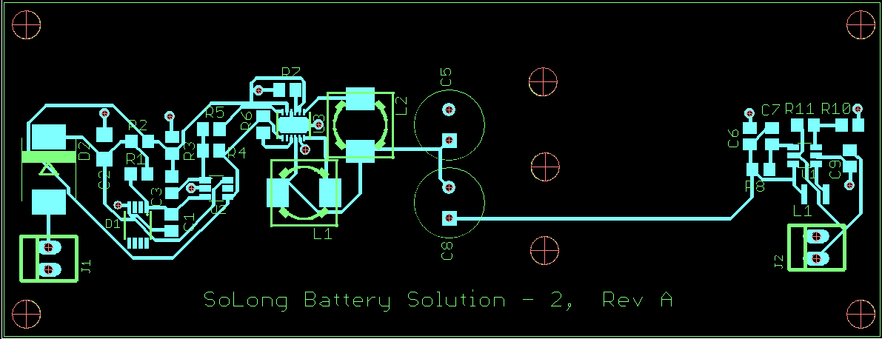

Figure 2.0-5:Layout Design 1:Top Layer
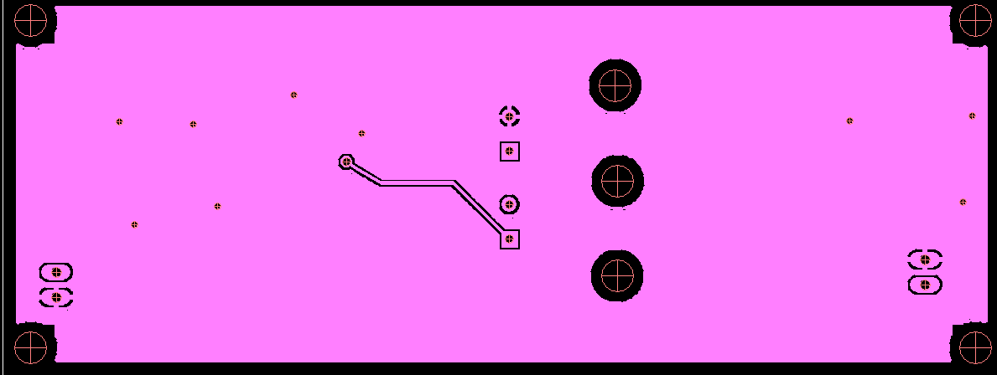

Figure 2.0-6:Layout Design 1:Bottom Layer
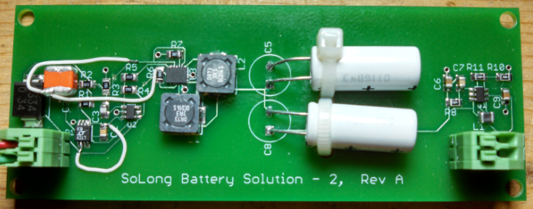

Figure 2.0-7:Assembled Design 1

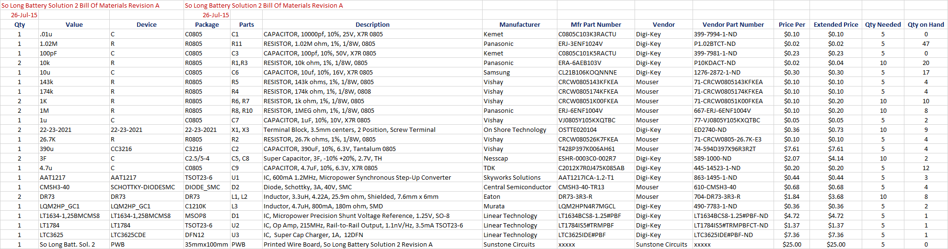

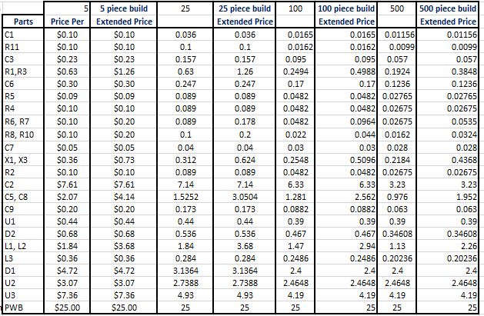

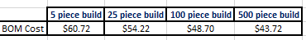
Figure 2.0-8:Design 1 Assembled Design BOM and cost estimates

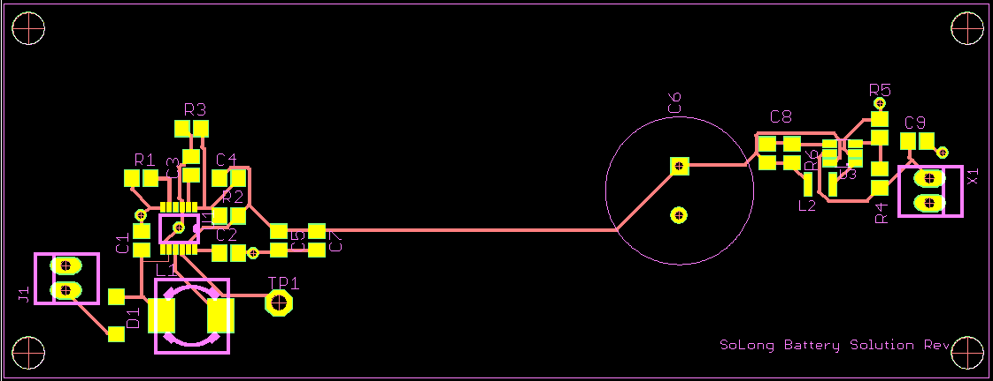

Figure 2.0-9:Layout Design 2:Top Layer

Figure 2.0-10:Layout Design 2:Bottom Layer
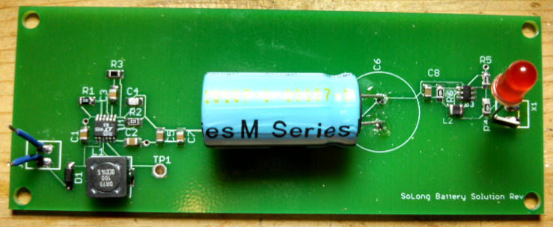

Figure 2.0-11:Assembled Design 2.
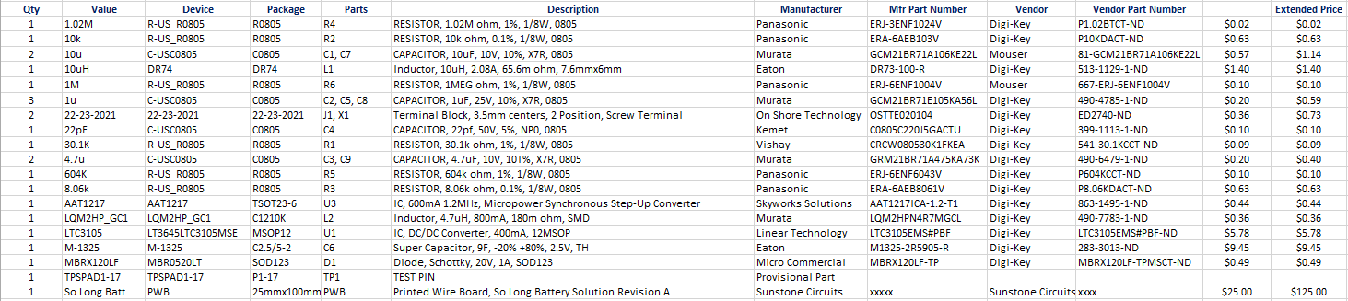

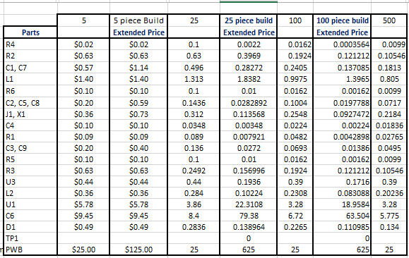

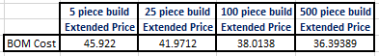

Figure 2.0-12: Assembled Design 2 BOM and cost estimates

Data
SoLong Battery Harvesting Solution Design 1 (5V):
Circuit Performance Based on Light Level
Power Supply V_{IN} | VDiode | V_{SuperCapacitor2}  (Volts) | Vbuck_{in}  (Volts) | V_{REG}  (Volts)
6.55 | 6.28 | .600 | 2.200 | 5.25
6.02 | 5.737 | .929 | 2.400 | 5.25
5.51 | 5.231 | .730 | 2.460 | 5.25
5.030 | 4.765 | .407 | 2.178 | 5.25
4.530 | 4.268 | .403 | 2.210 | 5.25
4.009 | 3.729 | .418 | 1.994 | 5.25
3.494 | 3.220 | .409 | 1.603 | 5.25
3.033 | 2.768 | .395 | 1.270 | 5.25
2.533 | 2.337 | .135 | 0.136 | 0.062
2.097 | 1.937 | .135 | 0.136 | 0.063
1.506 | 1.359 | .135 | 0.136 | 0.062
1.278 | 1.153 | .135 | 0.135 | 0.061
0.50 | .375 | .135 | 0.135 | 0.061
Figure 3.0-1: Design 1 Vin vs. Vout Data

Figure 3.0-2: Assembled Design 1 Vout vs. Vin Plot
SoLong Battery - Harvesting Solution Design 2:
Circuit Performance Based on Light Level
Solar Cell V_{IN} | VDiode | V_{SuperCapacitor}  (Volts) | V_{REG}  (Volts)
6.490 | 6.268 | 2.227 | 3.301
5.99 | 5.841 | 2.224 | 3.301
5.510 | 5.352 | 2.223 | 3.301
5.040 | 4.886 | 2.223 | 3.301
4.510 | 4.340 | 2.223 | 3.301
4.029 | 3.863 | 2.224 | 3.301
3.540 | 3.36 | 2.224 | 3.301
3.001 | 2.813 | 2.224 | 3.301
2.492 | 2.266 | 2.225 | 3.301
1.998 | 1.766 | 0.640 | 3.302
1.489 | 1.255 | 0.592 | 3.16
1.255 | 1.019 | 0.591 | 3.120
0.50 | .375 | .135 | 0.135
Figure 3.0-3: Design 2 Vin vs. Vout Data

Figure 3.0-4: Design 2 Vin vs. Vout Data

Packaging
The So Long Battery – Solar Harvesting electronics fabrication was originally intended to be constrained to the dimensions of an AAA battery bank (20mmx40mm) [1] footprint. The original packaging concept was to run a length of wire from the solar cell to the circuit board that would be sealed in a battery bank footprint style case. The premise for this was that consumers currently utilize battery packages now, therefore it would be easier to introduce a new technology if it could be made as a drop in replacement for the existing product. The difficulty with this concept however was the question of the solar cell. The cell is somewhat bulky with dimensions of 5 ¼” x 6 ¹/₂” x ¹/₈” which makes it awkward to expect a user to carry the cell while the mating end is mounted in their electronic device.
It became apparent that the solar cell could be utilized as part of the design to help strategically position the product. A concept was developed which utilized a fairly large off the shelf box (4 ⁷/₈” x 2 ⁷/₁₆ x 2 ¹/₈”) as a housing for the electronic circuitry. The circuitry would be mounted inside the housing and the cell would be mounted flat on the top cover. The construction would allow the user to place the product at an angle for morning and afternoon solar harvesting (Figure 4.0-1) or to position the cell flat for high noon solar collection (Figure 4.0-2). The design could then be marketed as a feature to be used for maximum solar harvesting.
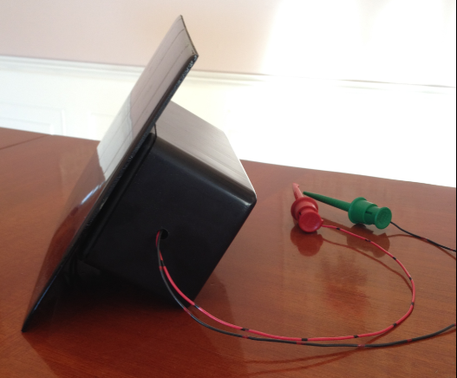
The case contained a pre-drilled mounting plate that the electronic assembly could be mounted to utilizing double sided tape. Holes with a ³/₁₆” diameter were drilled on both short side walls of the box, then the wires were passed through to allow access for the wiring (Figure 4.0-3) from the solar cell to the harvesting board and from the output of the harvesting board to a red clip for positive and a green clip for ground. The plate holding the board was then mounted to a shelf that was designed into the case, and the cover was added. The entire assembly was then locked together utilizing 4 screws that were provided with the case. Double sided tape was applied to the top area of the box, and then mounted to the rear of the solar cell.

Figure 4.0-1: SoLong Battery – Morning and Afternoon Harvesting Position
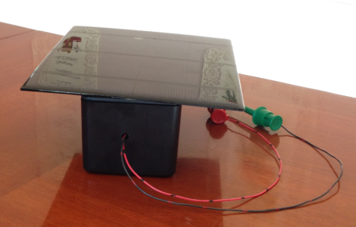

Figure 4.0-2: SoLong Battery – High Noon Harvesting Position
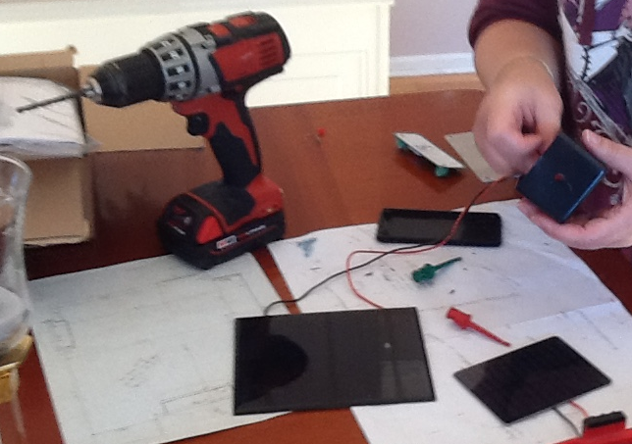

Figure 4.0-3: Assembly of the So Long Battery – Solar Harevster

Marketing
A Kickstarter project was launched on November 2, 2015. The product was launched as a prototype with no packaging. One goal of the launch was to see whether a feasible market existed for solar harvesters. Another goal of the launch was to determine whether there is backing available for the development of solar harvesting products. The design that had been developed to date required a re-spin and the data obtained through this product introduction was intended to help determine whether to proceed with a re-spin or to stop development efforts altogether. The project lasted a full month but was not successfully funded. The SoLong Battery – Solar Harvesting Solution was offered to backers for a contribution of $25 and required $5 for shipping and processing. There were 4 people that fully backed the product and then many backers signed on for a contribution ranging from $1 to $10. The final amount of funding that the project received was $125 and most would consider this a fail. There will be a second funding cycle launched in January 2016 with the final packaging and an improved video to try and increase the number of backers for the project.

Conclusion
The So Long Battery – Solar Harvester design was able to provide 5.25VDC at the output of the device when provided with an input voltage of 2.7VDC and higher gathered from a solar cell. This did not meet the original intent of the project which was to utilize indoor lighting as the light energy that was to be harvested by the design, therefore a second design effort had to be undertaken. This effort however, was an excellent attempt at providing a higher current 5VDC renewable energy power source if the input stimulus was higher than 2.7VDC. The device is capable of charging cell phones because of the constant power delivery ensured by the supercapacitor storage method. This market is in such demand that the application of the harvester and the cell phone creates a strong appeal for the development of a portable device that would keep phones powered.
Two downfalls of this design are the packaging and the size of the solar cell. If the solar cell could provide the same input power in a smaller package it would be more ideal for implementation in the portable electronic arena. In this case, an option would be to create a carrying case for the cell phones that would integrate the solar cell directly into the design which would make the implementation invisible to the end user. The current design is bulky and awkward. It is designed to be utilized by someone that is planning to be stationary for long periods of time. Convincing someone to attach the harvester to their electronic devices would be a hard sell.
The So Long Battery - Solar Harvester design number two worked the best of all the prototyped designs. The circuit had a stable output of 3.3 VDC when the Solar cell provided input voltage around 0.8VDC. The output voltage remained stable throughout the remaining input voltage spectrum from the solar cell. Based on the Solar cell chart in Table 1.6-1, the So Long Battery - Solar Harvesting Solution design 2 would work when the cell is exposed to bright ambient indoor light which was the goal of the original design specification.
Overall, solar cell technology is the limiting factor in harvesting systems because of the amount of available light that solar cells must have to provide reasonable power to the circuit input. Devices that are currently being developed can operate with 0.6 V input but the current delivery is so low, that the devices are impractical for use indoors. The work and analysis performed in this development effort has proven that a solar harvester will function indoors as long as there is a strong enough light source, or a direct line of sight to the sun through a window or glass door.

Historical Survey
Lead-acid batteries (Dry Cell) currently used to supply power to electronics are problematic because the concept that they were designed to was convenience and disposability. The volume at which these batteries are being purchased is an issue because the average consumer tosses them into the garbage once the battery is “dead”. The chemicals that they are made of can leach into the environment if the cases split open after they end up in a landfill. Lead-acid batteries are also problematic because they can’t compensate for the power fluctuations that are inherent in alternative energy harvesting systems [18]. Supercapacitors can help to provide a solution to the problem of lead acid batteries because they can compensate for the demands of instantaneous power that are created by the energy fluctuations in a harvesting device such as a Solar cell [18]. These power fluctuations stem from clouds passing by on a sunny day, or can be caused by moving the Solar cell collection device under a tree while walking. With lead acid batteries, these power fluctuations dramatically reduce battery performance and shorten their lifetime. Supercapacitors can help to provide a solution to the problem of lead acid batteries by replacing them with a low cost, long lasting, renewable solution.

One approach utilized to address the Dry Cell battery issues was to create a rechargeable storage device using chemicals that could be re-vitalized with the introduction of an electric current applied through the battery terminals. This product is a much better solution, but the issues of the Nickel and Cadmium leaching into the ground once the battery is discarded still existed. Recycling programs have been instituted to help with the problem but the issue still remains. Again, by creating a batteryless solution, the problem of chemical contamination in the environment is addressed [19].

There has been a growing requirement in the electronics industry for embedded systems that can operate without batteries and power adapters. Technology breakthroughs in recent years have improved power requirements of embedded systems. The size of these systems is being reduced, which leads to a smaller power consumption of the circuitry [20]. The Supercapacitor So-Long Battery- Solar Harvesting design is an attempt to create a self- powered regulated power supply. This work is important because it will help to establish the performance of a Solar charging supercapacitor circuit that will replace batteries.

The problem of battery replacement in mobile devices is also an issue that can be solved by utilizing the supercapacitor power unit. Supercapacitors are highly desirable components to use because unlike normal capacitors, they are not prone to failure over time due to the nature of their construction. Since the Supercapacitors keep their electrical properties because there is no electrolytic material that can dry out or weaken, they are more appealing to use in an energy harvesting system [20].

The need for photovoltaic charging systems, and the idea of power harvesting are presented as a solution to the power source issues that new designs in electronics will continue to have. By incorporating a power harvesting system into an actual design, demand may be created for improvement in Solar cell performance, and in size reduction of the collection cells [19]. My contribution to the field will be to prove, on a very small scale, that power harvesting works and that this technology is worth investing in. Although the power requirements for more advanced electronics is beyond the capability of supercapacitors on their own right now, further developments in this field will only enable the growth and capabilities of the power management systems being developed [20].

Most electronics are powered either by plug in power adapters, rechargeable batteries, or by disposable alkaline batteries. “Since the power source is not a major selling feature of the products people buy, low cost is the primary design consideration. In order to deal with the fact that every device has a unique power requirement, EPS [external power supply] units are designed to be dedicated to the specific devices they power” [21]. This one criteria is the biggest reason why so-called, “wall warts,” are such an issue. Every device that utilizes one spells out a specific connector, an internal power circuit structure, and a unique packaging style for their product. This can lead to having way too many wall adapters, and can be quite frustrating when you are looking for the adapter that you need for the specific product you want to use. In addition to the obvious consumer usage issues, these devices can be inefficient and waste energy in the form of the heat dissipation, and “vampire energy drain” which occurs when the product is fully charged yet the transformer is still acquiring energy. The supercapacitor solution will eliminate the need for wall warts altogether. It will have the same fit and function as a battery therefore there will be a commonality across the devices that will utilize it [21].
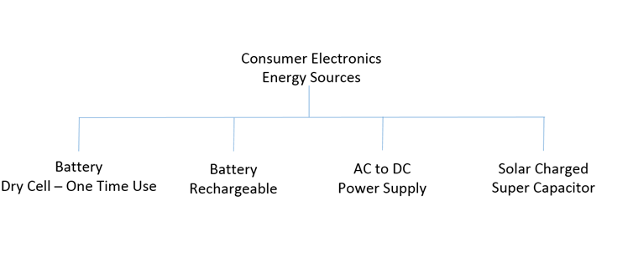

Figure 3.0-1 Taxonomy of Consumer Electronics Energy Sources

Literature Survey:
[1] 2015 Apr. 28. "Energizer Technical Information." [online]. Available: http://data.energizer.com

[2] Nathan Bourgoine. “Harvest Energy from a Single Photovoltaic Cell”. Linear Technologies Journal of Analog Innovation 21.1(2011):1.
http://cds.linear.com/docs/en/lt-journal/LTJournal-V21N1-2011-04.pdf.

[3] Tan, Y.K.; Panda, S.K., "Energy Harvesting From Hybrid Indoor Ambient Light and Thermal Energy Sources for Enhanced Performance of Wireless Sensor Nodes," Industrial Electronics, IEEE Transactions on, vol.58, no.9, pp.4424-4435, Sept. 2011
doi: 10.1109/TIE.2010.2102321
URL: http://ieeexplore.ieee.org/stamp/stamp.jsp?tp=&arnumber=5675682&isnumber=5979518

[4] Hsu, J.; Zahedi, S.; Kansal, A.; Srivastava, M.; Raghunathan, V., "Adaptive Duty Cycling for Energy Harvesting Systems," Low Power Electronics and Design, 2006. ISLPED'06. Proceedings of the 2006 International Symposium on, vol., no., pp.180-185, 4-6 Oct. 2006
doi: 10.1109/LPE.2006.4271832
URL: http://ieeexplore.ieee.org/stamp/stamp.jsp?tp=&arnumber=4271832&isnumber=4271789

[5] Hui Shao; Chi-Ying Tsui; Wing-Hung Ki, "A micro power management system and maximum output power control for Solar energy harvesting applications," Low Power Electronics and Design (ISLPED), 2007 ACM/IEEE International Symposium on , vol., no., pp.298,303, 27-29 Aug. 2007 doi: 10.1145/1283780.1283844
URL: http://ieeexplore.ieee.org/stamp/stamp.jsp?tp=&arnumber=5514309&isnumber=5514251

[6] 2015 Apr. 28. “Radio Shack 1W, Solar Panel, 6V”, model P1060”. [online]. Available: http://www.radioshack.com/radioshack-1w-Solar-panel-6v/2770049.html

[7] Linear Tech "1A High Efficiency 2-Cell Supercapacitor Charger with Automatic Cell Balancing," TC3625/LTC3625-1 data sheet, 2010

[8] Lei, HAN, WANG Xia, and WANG Guangwei. "Maximum Power Point Tracking For The Micro-Scale Photovoltaic Power System." Applied Mechanics & Materials 734(2014): 771-774. Engineering Source. Web. 27 Apr. 2015.

[9] Zuo Xuewen; Li Guo-Zheng, "ISoated voltage balancing in super-capacitor energy storage system," Control and Decision Conference (2014 CCDC), The 26th Chinese , vol., no., pp.5124-5128, May 31 2014-June 2 2014 doi: 10.1109/CCDC.2014.6853093
URL: http://ieeexplore.ieee.org/stamp/stamp.jsp?tp=&arnumber=6853093&isnumber=6852105

[10] Adrian Schneuwly, Roland Gallay, 28 April 2015. “Properties and applications of supercapacitors from the state-of-the-art to future trends.pdf”. PCIM 2000 [online]. Available: www.garmanage.com/atelier/root/public/Contacting/biblio.cache/PCIM2000.pdf

[11] Microchip "Low Noise, Positive-Regulated Charge Pump" datasheet, 20024

[12] Arjan M. van Voorden, A.M.; Elizondo, L.M.R.; Paap, G.C.; Verboomen, J.; van der Sluis, L., "The Application of Super Capacitors to relieve Battery-storage systems in Autonomous Renewable Energy Systems," Power Tech, 2007 IEEE Lausanne , vol., no., pp.479-484, 1-5 July 2007 doi: 10.1109/PCT.2007.4538364
URL: http://ieeexplore.ieee.org/stamp/stamp.jsp?tp=&arnumber=4538364&isnumber=4538278

[13] 2015, Apr. 28. “DC1583A-A - LTC3625EDE Demo Board | VIN = 2.7V to 5.5V, VOUT= 5.3V / 4.8V @IOUT up to 1A [schematic]” [Online]. Available: http://www.linear.com/Soutions/3760

[14] Cap XX,"HS230 / HS130 Supercapacitor" Datasheet, Rev 1.0, Jun 2010

[15] Editorial Staff. 2012, Jun 27. “The World of Alkaline Batteries” [online]. Available: http://www.batterypoweronline.com/main/markets/batteries/the-world-of-alkaline-batteries/

[16] 2015, Apr. 28. “Monthly battery sales statistics” [Online]. Available: http://www.baj.or.jp/e/statistics/02.php

[17] Linear Tech "400mA Step-Up DC/DC Converter with Maximum Power Point Control and 250mV Start-Up," LTC3105 data sheet, 2010

[18] Chalasani, S.; Conrad, J.M., "A survey of energy harvesting sources for embedded systems," Southeastcon, 2008. IEEE , vol., no., pp.442-447, 3-6 April 2008 doi: 10.1109/SECON.2008.4494336
URL: http://ieeexplore.ieee.org/stamp/stamp.jsp?tp=&arnumber=4494336&isnumber=4494235

[19] England, C.N., "The national collection and recycling program for nickel-cadmium rechargeable batteries," Battery Conference on Applications and Advances, 1995., Proceedings of the Tenth Annual , vol., no., pp.77-81, 10-13 Jan 1995
doi: 10.1109/BCAA.1995.398504
URL: http://ieeexplore.ieee.org/stamp/stamp.jsp?tp=&arnumber=398504&isnumber=9002

[20] Moser, C.; Thiele, L.; Benini, L., "Design of a Solar-Harvesting Circuit for Batteryless
Embedded Systems," Circuits and Systems I: Regular Papers, IEEE Transactions on , vol.56, no.11, pp.2519-2528, Nov. 2009 doi: 10.1109/TCSI.2009.2015690
URL: http://ieeexplore.ieee.org/stamp/stamp.jsp?tp=&arnumber=4785219&isnumber=5308577

[21] Panepinto, P.A., "Making power adapters smarter and greener," Sustainable Systems and Technology, 2009. ISSST '09. IEEE International Symposium on, vol., no., pp.1-5, 18-20 May 2009 doi: 10.1109/ISSST.2009.5156696
URL: http://ieeexplore.ieee.org/stamp/stamp.jsp?tp=&arnumber=5156696&isnumber=5156678

Appendix A: Schedule
A.1 The following chart is the comprehensive schedule for the So-Long Battery – Solar Harvesting project. This time line covers the effort required during the Readings course. The formulation of the project and the scope of the work is outlined during this timeframe.
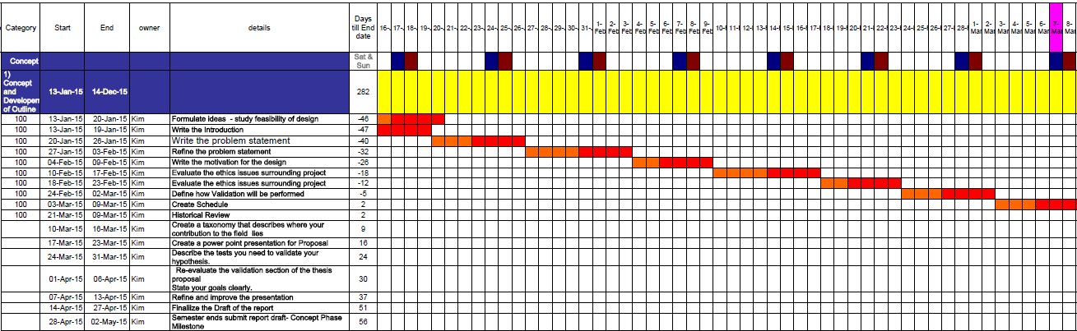

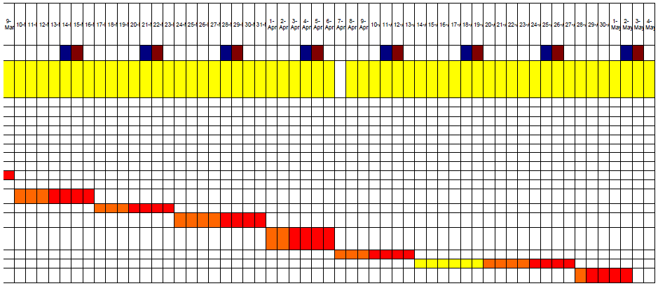

A.2 The following chart is the schedule for the objectives set during the Thesis I semester.
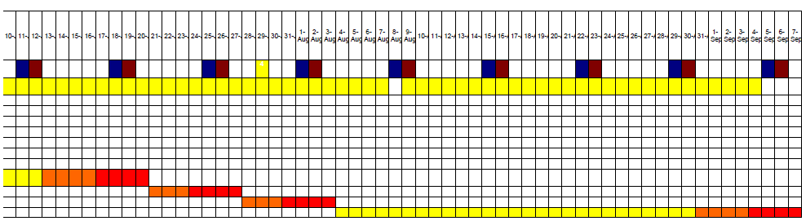
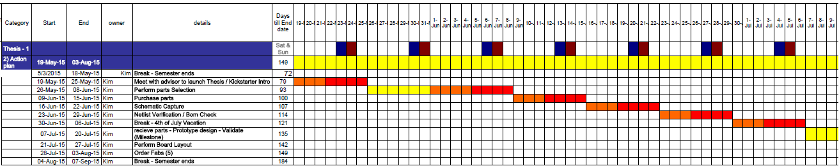

A.3 The following chart is the schedule for the objectives set during the Thesis II semester.
