To do a course code build on the mac
- 1st, download jdk1.8
https://www.oracle.com/technetwork/java/javase/downloads/jdk8-downloads-2133151.html?ssSourceSiteId=otnpt
- 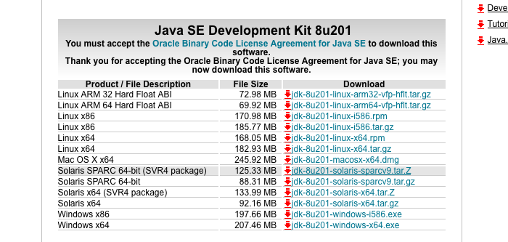

install the correct jdk for your machine. Then download the Community Edition of Intellij for the correct machine from:
https://www.jetbrains.com/idea/download/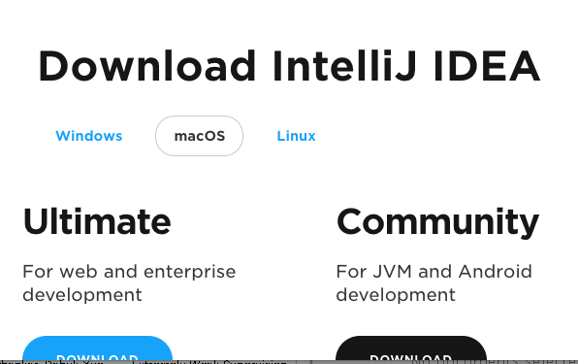
now download the code from blackboard:
this is a jar file. You may unjar it with the command:
jar –xvf all.jar
or you may use 7zip or winzip.
When you are done, you will have a j4p folder with the src and the jars;
/Users/lyon/current/java/j4pCode
mini{lyon}108: ls
jars/ src/

You may now start intellij Click, create a new project:
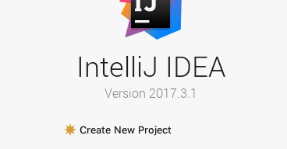
select a project sdk (jdk1.8):
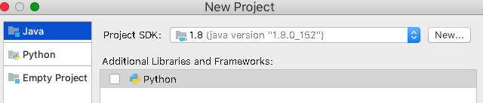
you may have to browse into your program files\java directory to find the jdk1.8 (for windows). On the mac it is under Library/Java/JavaVirtualMachines/
Hit next until you get to the new project dialog;
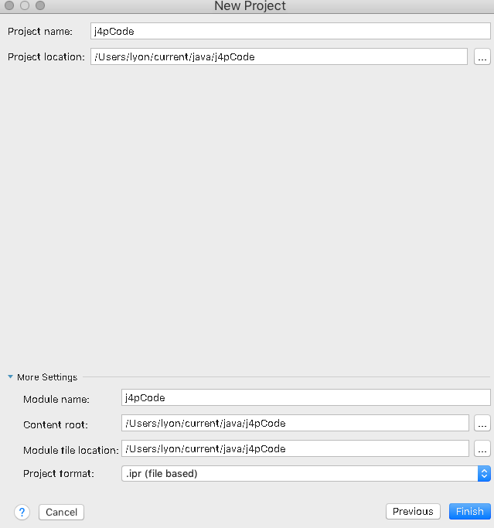
then click finish.
Select the jars at the top-level of the jars folder;
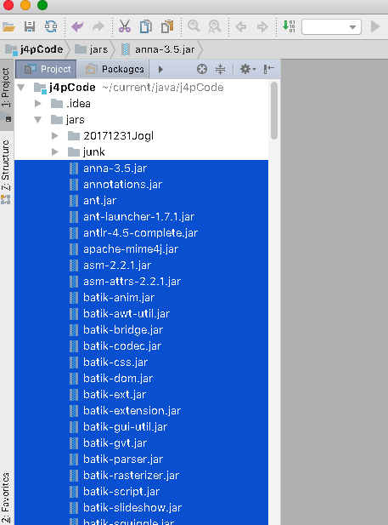
mouse right, select add as library…
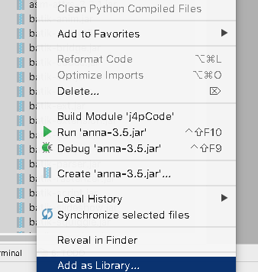
and click ok.
Open the jogl jar folder and select the contents;
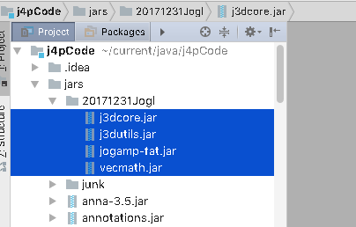
mouse right and add it to the library too:
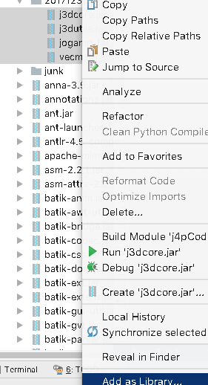
click ok
open the preferences. Select bytecode version 1.8 for the output;
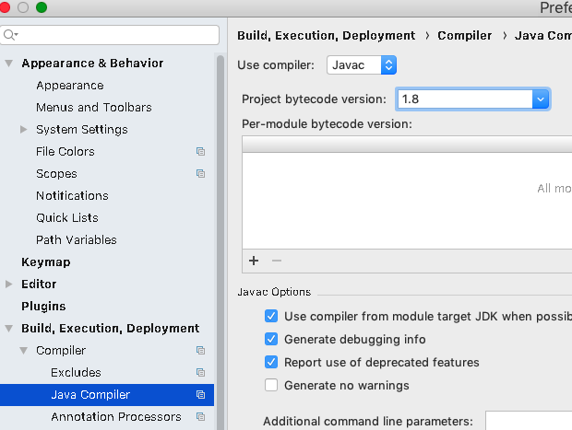
configure your compiler build heap with extra ram;
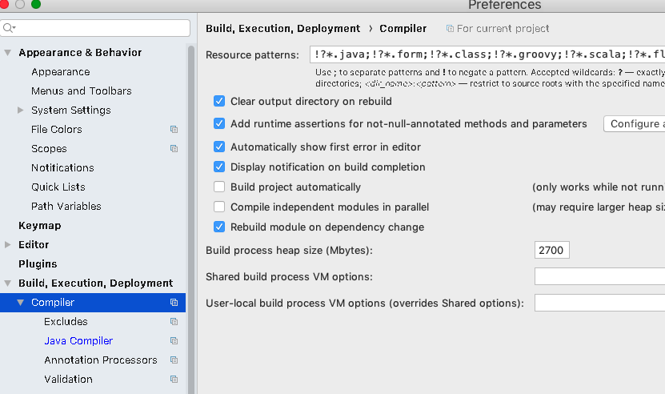
I used 2700 Mbytes. Hit Apply and OK.
Select HelloWorld and mouse right to build the project.
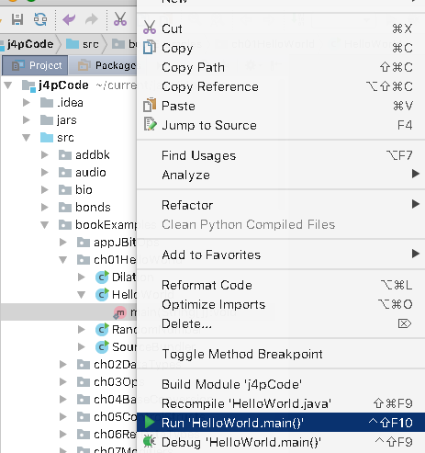
When it is done, you should see an output:
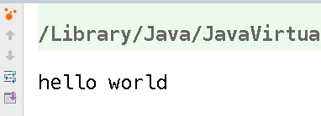
Congrats! You have done a proper build!!

