Servlet Tutorial Using The Eclipse Plugin MyEclipse IDE

Jaime S. Katz
SW 410
Homework #6
12/10/2007

Technology Utilized

- Microsoft Windows XP Professional
- Eclipse 3.3.1
- MyEclipse Enterprise Workbench 6.0 (includes Java JDK 1.6)
- Tomcat 6.0

Tutorial

- Launch MyEclipse.
- Create a workspace in MyEclipse by either using the default eclipse workspace and selecting “OK”; or creating a new workspace by selecting “browse” in the Workspace Launcher (if the default workspace is used, go to step 4) ) :

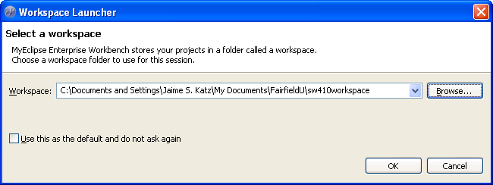

- Select “Make New Folder”; name it; select “OK”:

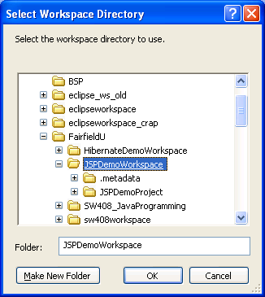

- Create a new web project (select “web project”):

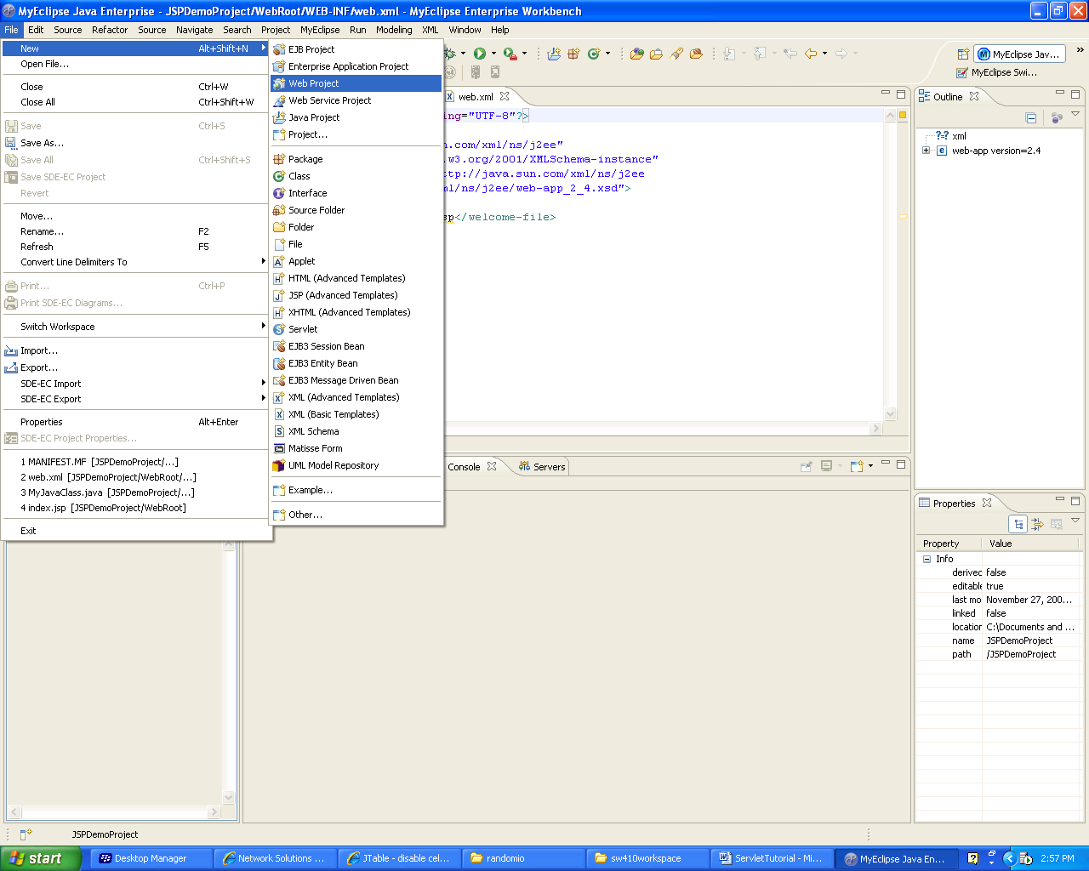

- Name the project “ServletDemoProject”:

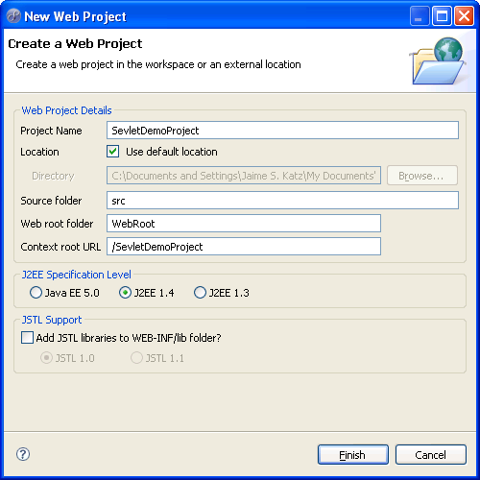

- Default web.xml and index.jsp files are created when the project is created:

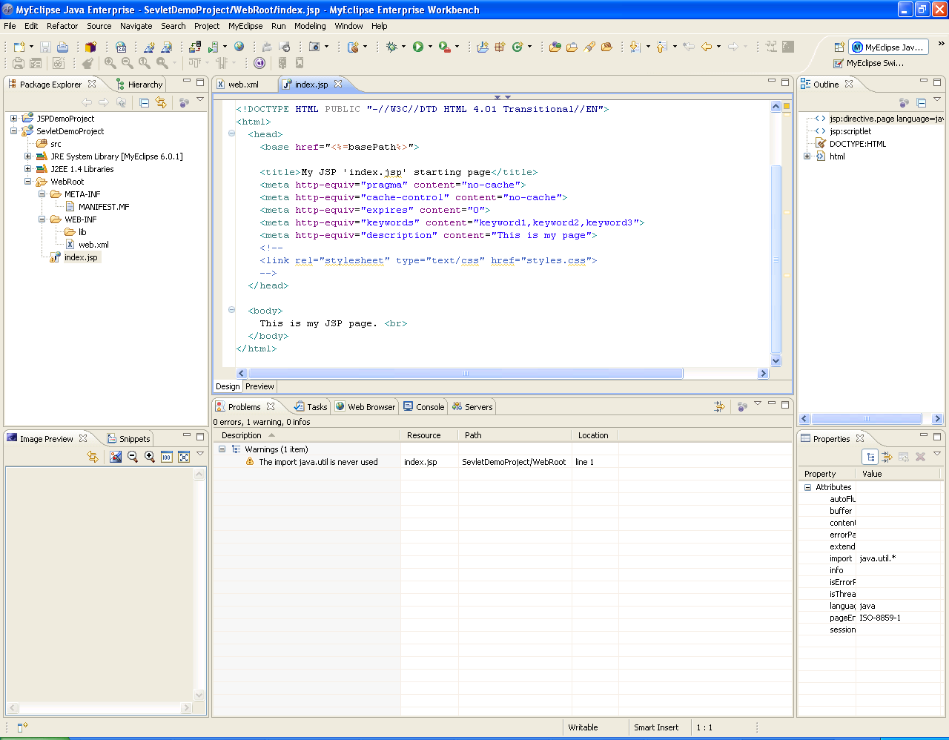

- Create the servlet by right-clicking on the package where the servlet will be stored. Select “New” and “Servlet”:

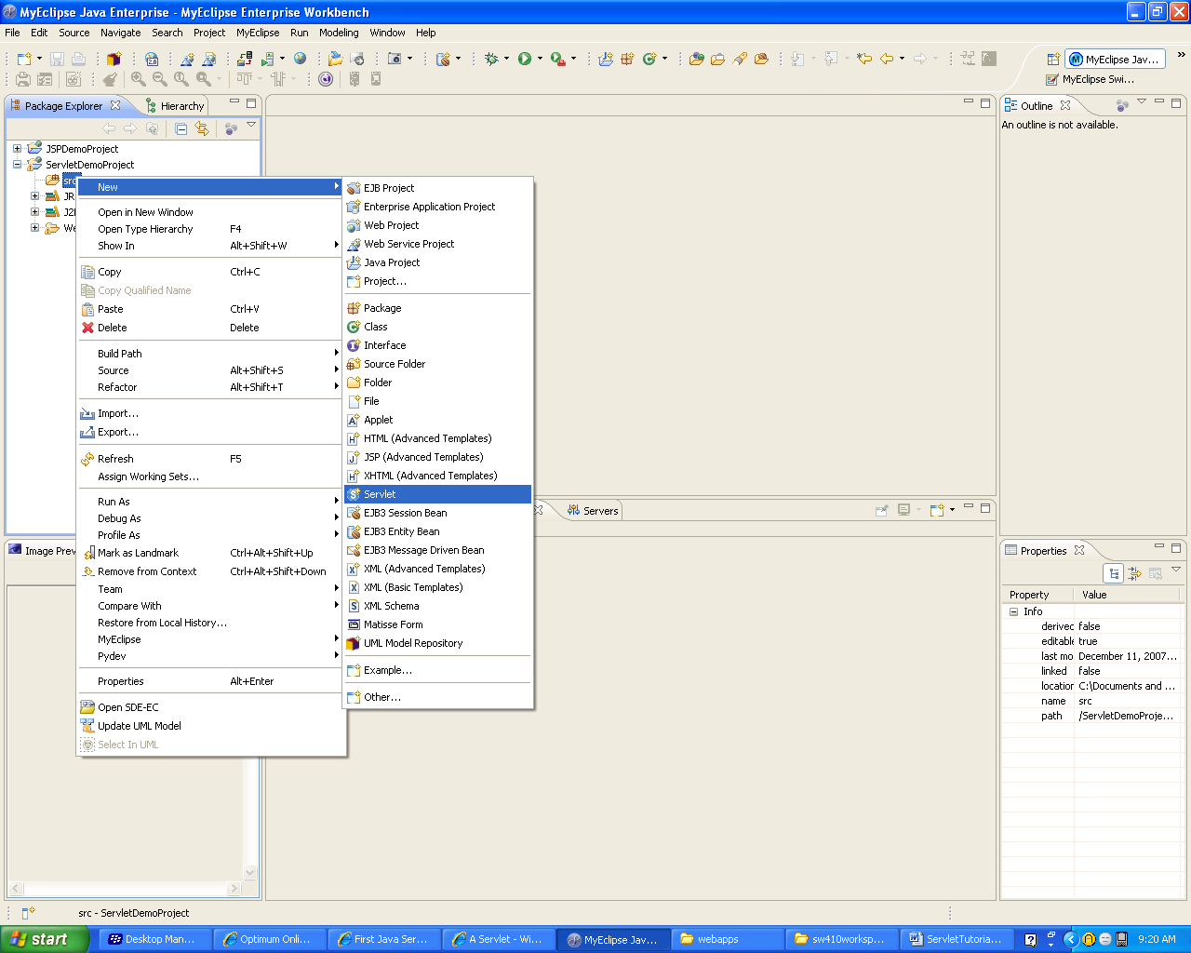

- The Servlet Wizard will then appear. Name it “Hello” and use its defaults. Select “Next”:

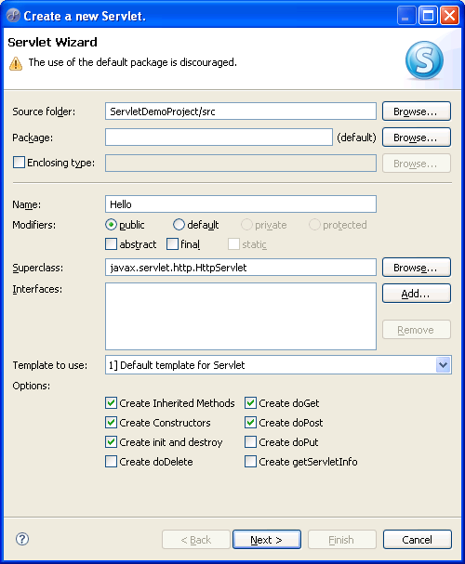

9) Map the “Servlet/JSP Mapping URL” to “/Hello”:

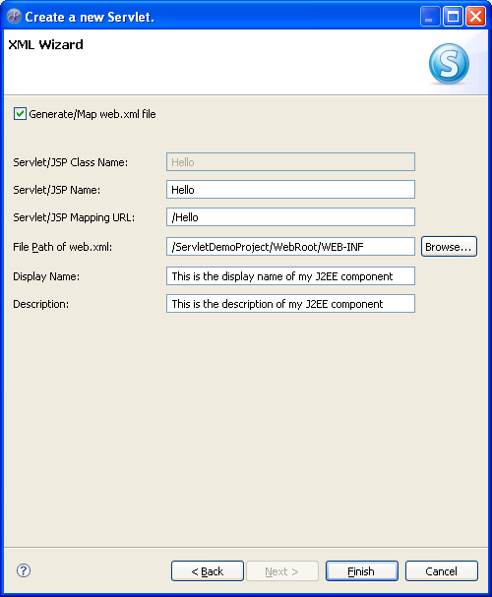

- Notice that the web.xml file is updated and the Hello.java (containing the “doGet” and the “doPost” methods) file is created:

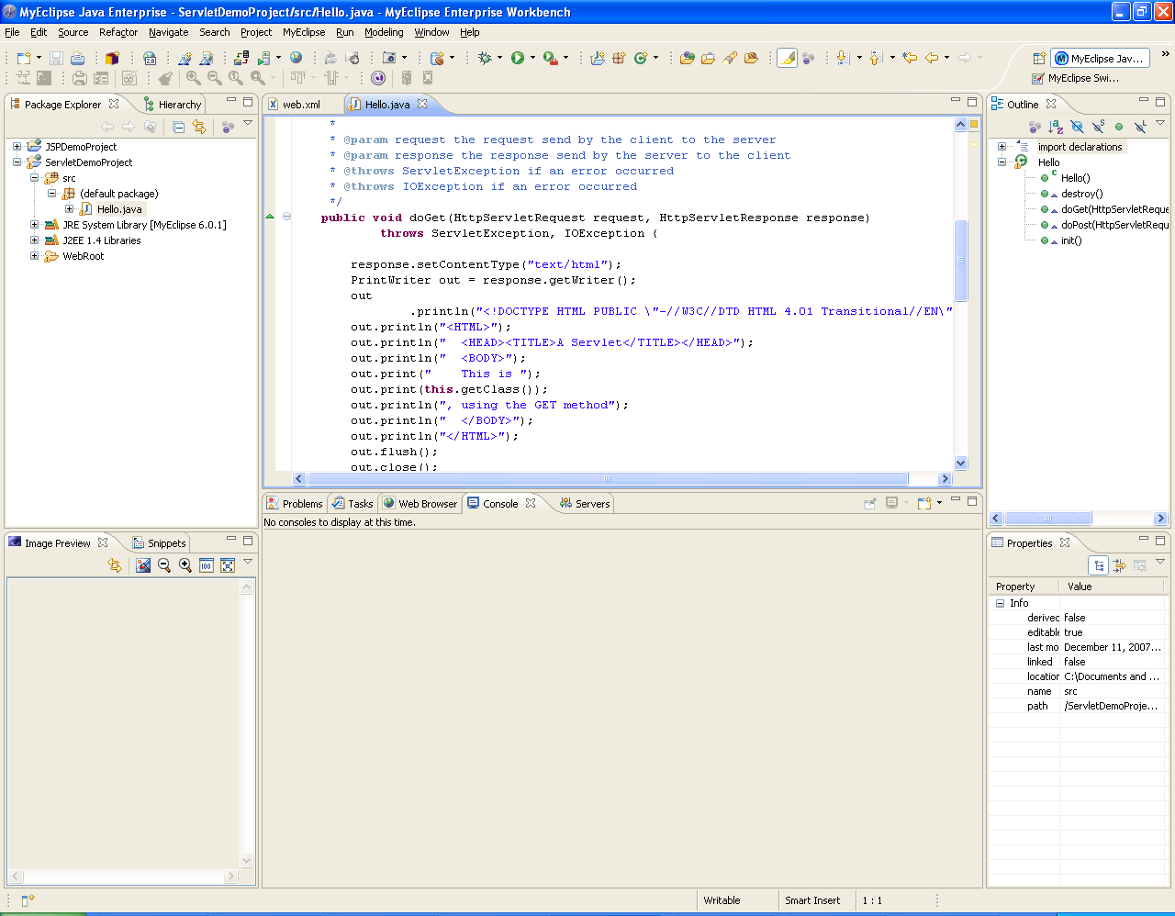

The project is ready for deployment.

- Configure the application server (select “configure server”):

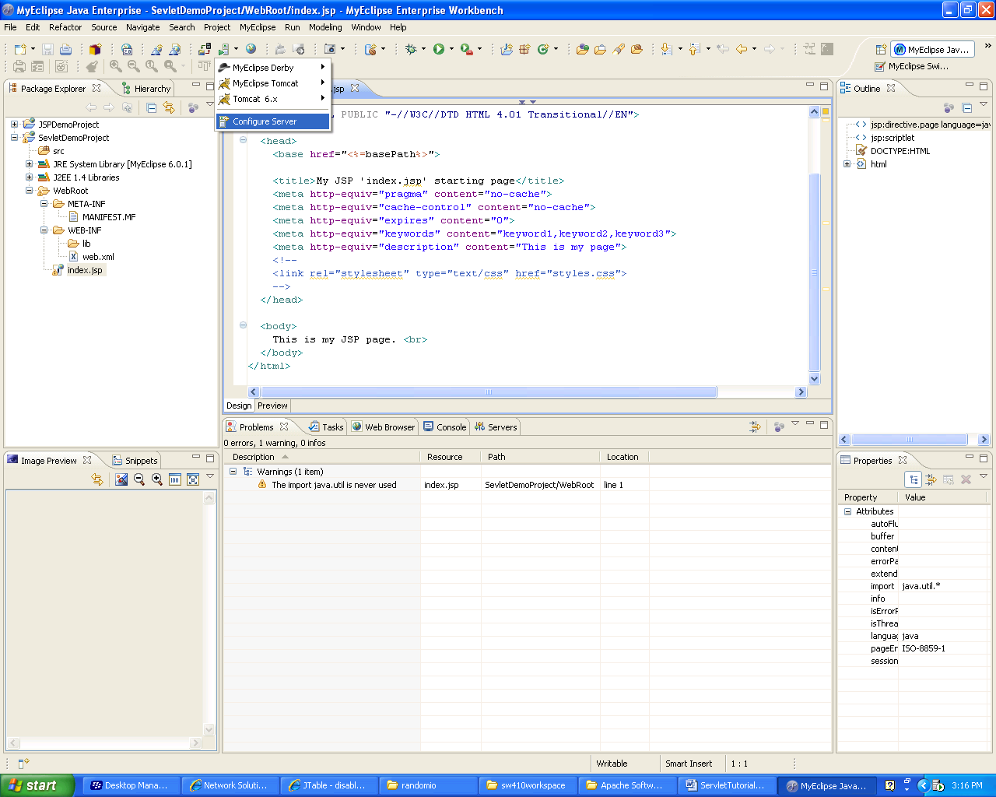

- Select “Tomcat 6.0”; “browse” to the Tomcat Home Directory

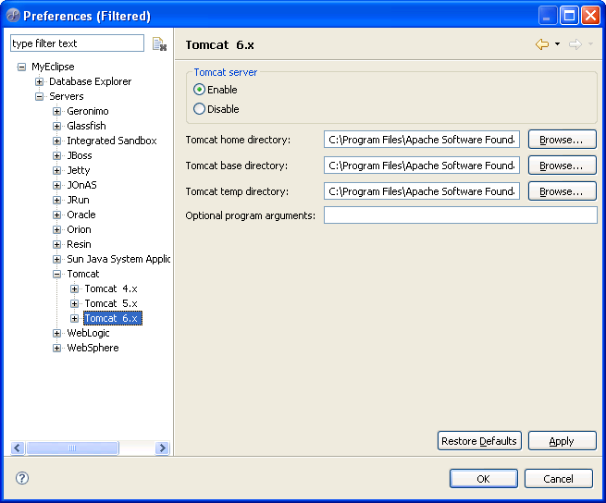

The Tomcat server will be started externally to the MyEclipse IDE (see step 13)). The servlet will be executed in an external browser.

- Deploy the project:

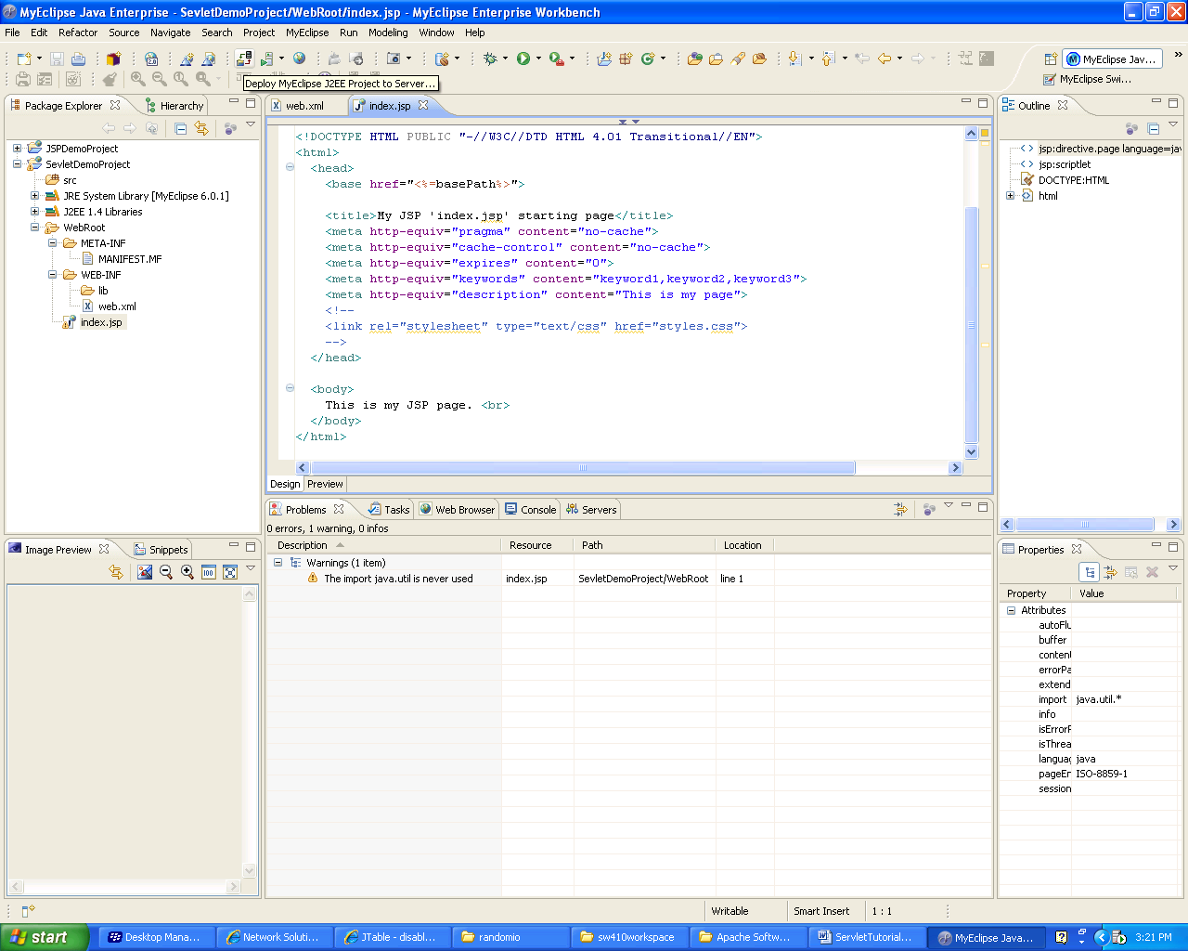

- Select project for deployment; select “add” to add the project to the application server:

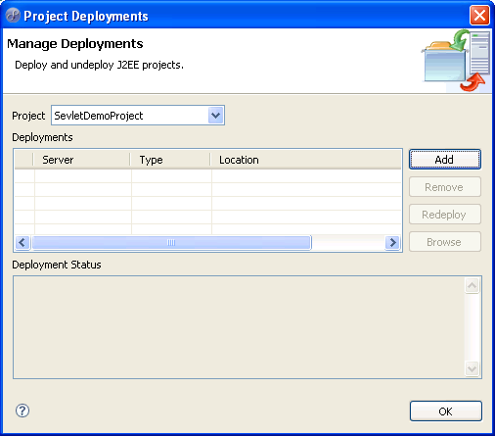

- Select the server and then “finish”:

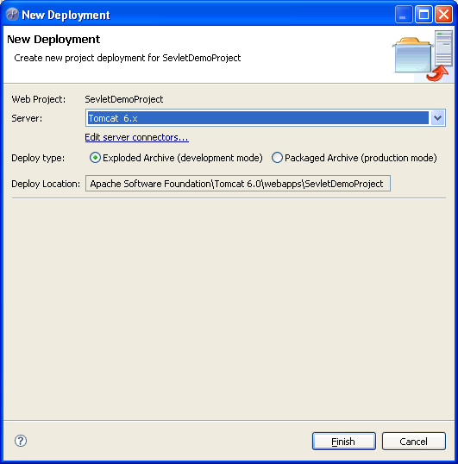

- The project is deployed; select “OK”:

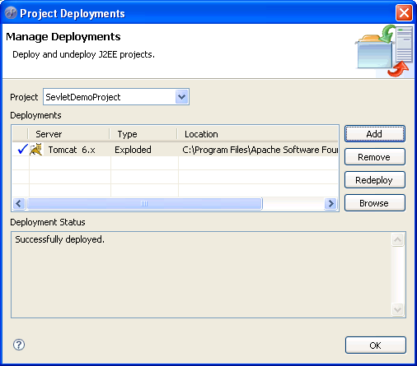

- Start the Tomcat server (I used Control Panel/Administrative Tools/Services):

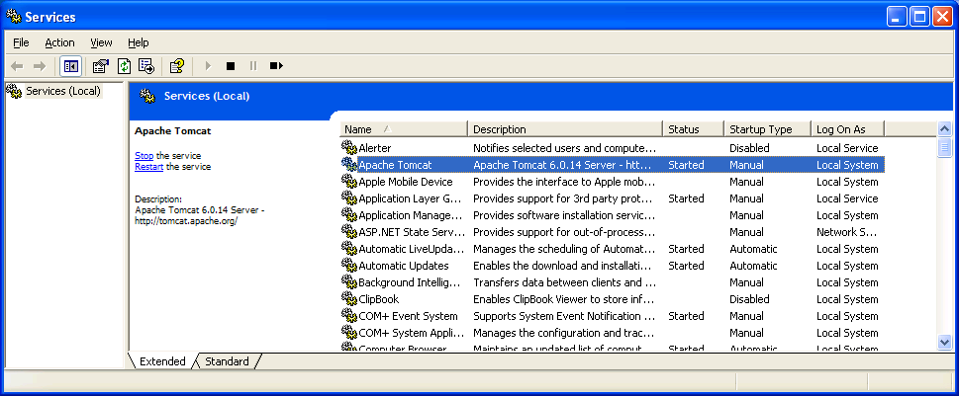

- Execute the servlet “Hello” in the browser at the specified url:

http://127.0.0.1:8080/ServletDemoProject/Hello

